Sitemap:
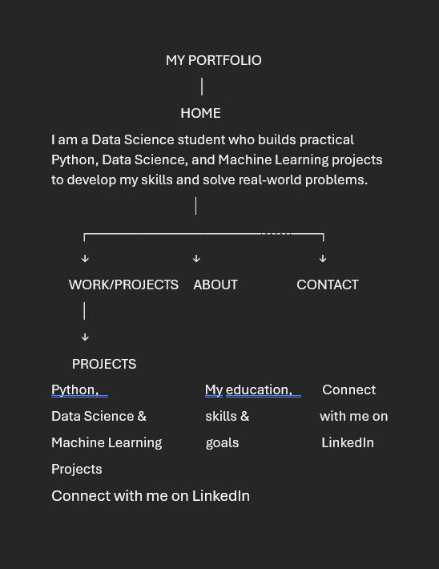
Claude Project:
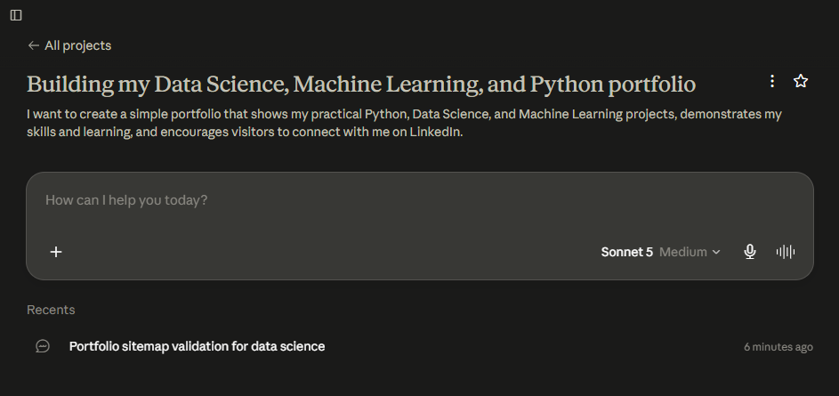

Custom Instructions:
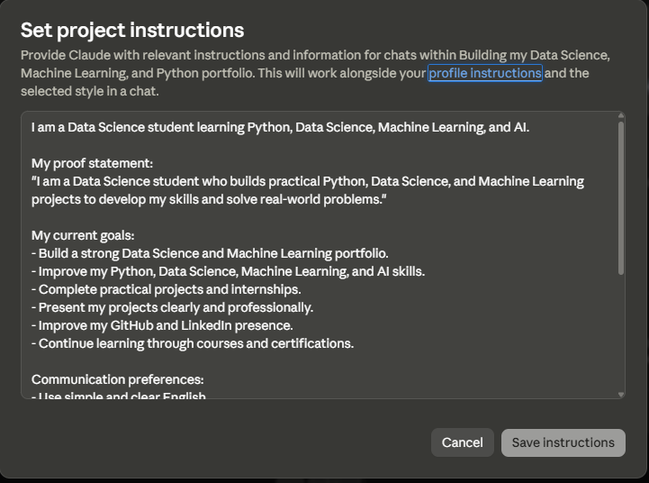

Change I Will Make:
I will make the About section focus on my motivation, learning approach, and goals instead of making it a generic biography. I will also add a small LinkedIn connection button on the Home and Work/Projects sections so visitors can connect when they are most interested in my work.

Pressure-Test Prompt + Claude Output:
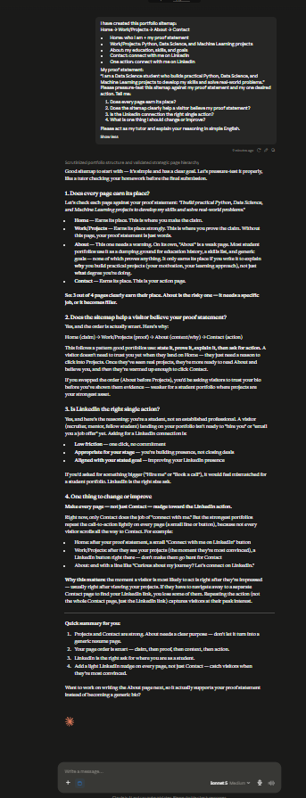

Gemini account:
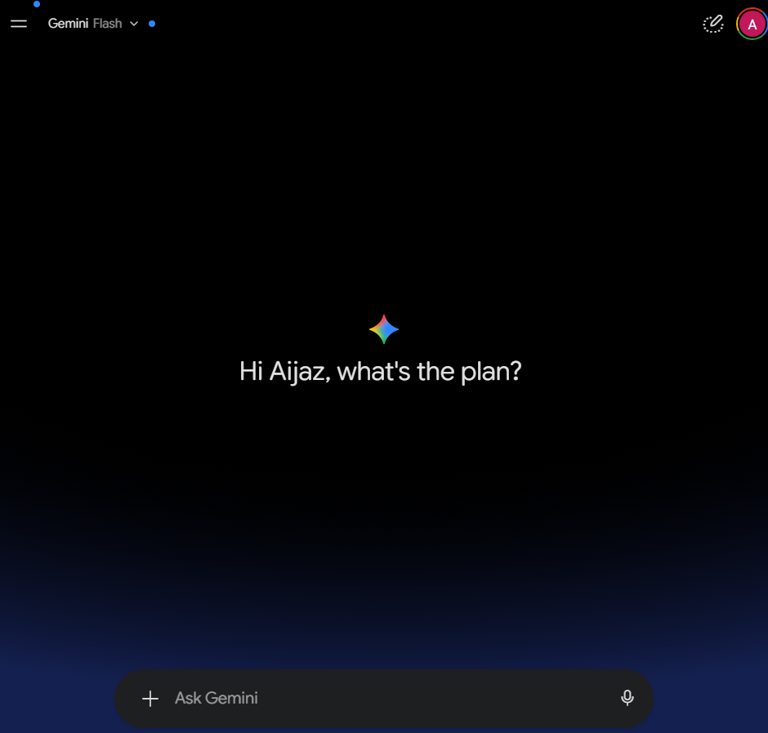

Perplexity account:
